МИНИСТЕРСТВО НАУКИ И ВЫСШЕГО ОБРАЗОВАНИЯ  
РОССИЙСКОЙ ФЕДЕРАЦИИ

федеральное государственное автономное   
образовательное учреждение высшего образования  
«Самарский национальный исследовательский университет   
имени академика С.П. Королева»

(Самарский университет)

Институт информатики, математики и электроники

Факультет информатики  
Кафедра суперкомпьютеров и общей информатики

**Отчет по лабораторным работам № 2**

Дисциплина: «Enterprise Systems Development (Методы проектирования и поддержки требований к программному обеспечению)»

Тип предприятия: **«Social Network»**

Тема: **«Specification of system requirements. Use Case diagram»**

Выполнила: Курбатова О.В.

Группа: 6133-010402D

Самара 2021

# Assignment #2 Use Case Scenarios

Objective: To study the basic features for creating and editing scenarios for use cases

## Tasks

1. Write scenario for each use case using template: use case name, actors, goal, short description, basic script, exceptions (if exist).

2. Complete scenarios with examples of documents to be created by your information system. For example, Bill in cafe, Internet invoice, Order in the online store, Medical services bill, etc.

**Assignment #2. Use Case Scenario**

**Task 1**

**Use case 1: registration and log in the Social Network Site**

Actors: user, admin

Purpose: registration in the social network site to gain access to personal page

Short description: user visits the site. It gets to the start page of the site. It is registered in the system.

Specification:

1. The user goes to the site (on the start page);

2. The user see information message: Need to log in with Google

3. Enters Google email, press "log in" button.

Exception 1: user has not a Google Account;

Exception 2: this mail is already registered in the system.

4. The user is registered.

**Use case 2: Send message**

Actors: User.

Purpose: Publish a text message on a personal page of the user

Short description: The user opens its page, the "Message" field enters the text and publishes it.

Specification:

1. The user opens a personal page on the site;

2. In the form of entering the message dials text

3. Press the Save button

4. The message publishes to the user page

**Use case 3: Edit message**

Actors: User.

Purpose: change the previously sent message on the user page

Short description: The user opens his page, sees a list of previously sent messages, edits its content

Specification:

1. The user opens a personal page on the site;

2. The user selects a message from the list of previously published and clicks the "Edit" button

3. In the form of entering the message dials text

4. Press the Save button

5. The message varies on the user page

**Use case 4: Delete message**

Actors: User.

Purpose: Delete the previously sent message on the user page

Short description: The user opens its page, sees a list of previously sent messages and deletes one message

Specification:

1. The user opens a personal page on the site;

2. The user selects a message from the list of previously published and clicks the "Delete" button.

3. The message is removed from the user page

**Use case 5: Publish post**

Actors: User.

Purpose: Publish post on Personal User Page

Short description: The user opens its page, the message field downloads the file and publishes it.

Specification:

1. The user opens a personal page on the site;

2. In the message form, click the Download File button

3. In the window that opens, selects a file that wants to load and clicks "OK" button

Exceptions1: File of the Unsuitable Format: The user will see a message: "Select a file to download in JPG OR PNG format"

Exceptions 2:Wrong File: The user will see a message: "Select a file for loading the size of MAX 3MB"

4. Click the "Save" button

5. Post publishes on the user page

**Use case 6: Delete post**

Actors: User, Admin

Purpose: Delete Post on Personal User Page

Short description: The user or admin opens the user page, sees a list of posts published earlier.

Specification:

1. User / Admin opens a personal page on the site;

2. User / Admin selects a post from the list of posts, previously published and clicks the Delete button.

3. Post deleted from custom page

**Use case 7: Temporary user block / ban user**

Actors: Admin

Purpose: Block the user for a while

Short description: Admin opens the user page presses the BAN button, indicates the time blocking period

Specification:

1. Admin opens a personal user page on the site;

2. Admin clicks on the Ban button to block the user.

3. In the pop-up window appears input of the blocking period

4. Admin Indicates the dates of the user blocking and clicks the "OK" button

5 User temporarily blocked

**Use case 8: Delete user**

Actors: Admin

Purpose: Delete a user profile for always

Short description: Admin opens the user page and removes his social network profile forever

Specification:

1. Admin opens a personal user page on the site;

2. Admin clicks on the Delete button

3. A form with a question appears in the pop-up window: Are you sure you want to delete a custom page?

Exception 1. If the admin managed to "Delete" the "Delete" button on the user page, then the Admin pop-up presses the "Cancel" button

4. Admin clicks the "OK" button

5. Custom page removed

**Task 2**

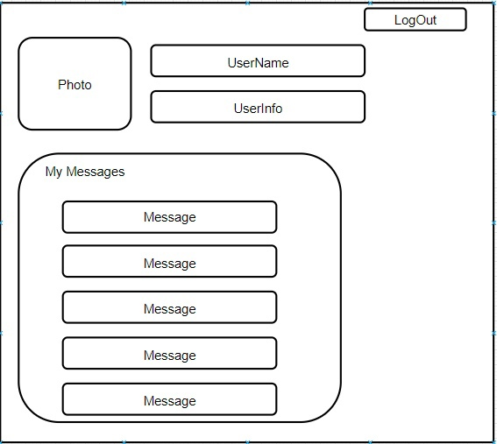

Image 1. Layout Custom Page

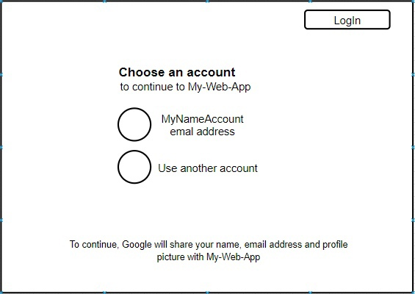

Image 2 - Layout registration and login form

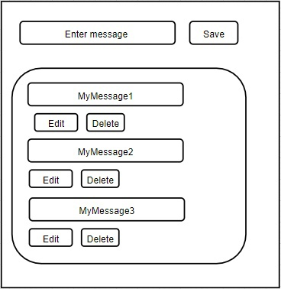

Image 3 – Layout message form

**Conclusion**

In the course of the work, use case scenarios were described and a custom page layout, messaging form and registration form layouts were developed.